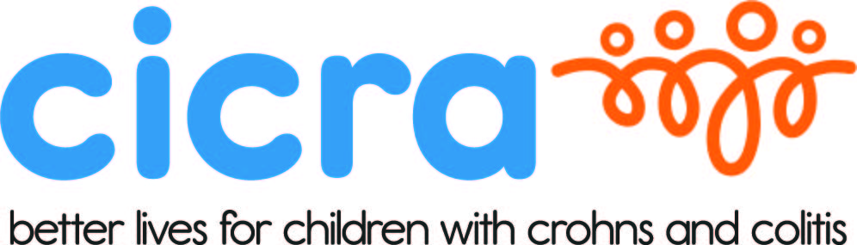

CICRA 200+ CLUB – CONSTITUTION

A Private Lottery under the
Lottery and Amusements 1976 Act
Please note: Membership of CICRA is free and to comply with the “private lottery” rules, anyone signing for membership of the 200 Club will automatically become a member of CICRA without any cost or obligation.

- AIMS – To raise funds for Crohn’s in Childhood Research Association, (The Association) registered charity numbers:
England & Wales 278212, Scotland SC040700, for research into the cause of Inflammatory Bowel Disease.

- MEMBERSHIP of the 200 Club is open to anybody age 16 or over

- SUBSCRIPTIONS – Annual subscription is £26 payable by Standing Order, Cheque, Credit Card or Bank Transfer

- BENEFITS – (Based on full complement of 200 members)-

  - Quarterly – A ballot of all members fully paid up in the month preceding each ballot will take place every third month and will be known as the Quarterly Draw. The first number drawn will receive a prize of £250 and the second and third numbers will each receive a prize of £75

  - Note If a full complement of 200 members is not reached, the quarterly prizes will be in proportion to the number of members.

  - Monthly – Excluding the four months in which the Quarterly Draw takes place, a ballot of all paid-up members will take place in the remaining eight months and will be known as the Monthly Draw. The first and second numbers drawn will each receive prizes of £50.

  - After the deduction of minimum administration costs, the whole proceeds shall be divided between the provision of prizes and the purposes of The Association.

- PRIZE WINNERS – Individual winners will be notified by post or email. A full list of winners for each half year will be advertised in the ‘Insider’ Newsletter.

- MANAGEMENT – the promoter is Mrs Tammy Migliaccio. Any dispute with regards to the 200+ Club that cannot be settled with the promoter, will be referred to the Association’s Trustees who will give a ruling binding on all parties.

- CONDUCT OF THE QUARTERLY AND MONTHLY DRAWS – Each draw will take place by the promoter at the CICRA Office at Pat Shaw House, Sutton in the presence of at least two members of the CICRA staff or Trustees. Any member may apply to attend the draws.

- MEMBERS’ AGREEMENT ON JOINING – So that prizes, benefits and funds can be maintained, those joining are asked to remain members for at least twelve months. However, this agreement can be waived if personal circumstances warrant it. Please notify admin@cicra.org if you do not wish to renew your subscription or stop your standing order so that your number can be used again. Also please notify admin@cicra.org if you change your address or email address.
- ACCOUNTS – All members have the right to inspect the records of the Club, on reasonable notice having been given, at Pat Shaw House, 13-19 Ventnor Road, Sutton, Surrey , SM2 6AQ

www.cicra.org | support@cicra.org | 020 8949 6209
Crohns in Childhood Research Association (CICRA)
Pat Shaw House, 13-19 Ventnor Road, Sutton, Surrey, SM2 6AQ
a registered charity in England & Wales, number 278212 and Scotland, number SC040700

